DevOps

EC2 2

EC2 Overview 2

EC2 Families & Instance Types 5

Volumes in EC2 7

EBS 10

EBS Snapshots 12

How to move a volume from one AZ to another AZ 15

Images 17

Key Pair 19

EC2 Authentication & Active Directory Integration 21

EC2 Placement Groups 22

EC2 Security Groups & Network Access Control 24

SG Design for EC2 26

Network Access Control List (NACL) 28

Auto Scaling 30

Elastic Load Balancer 32

Types of IPs 36

EC2 7 Steps 38

EC2 Hibernate 39

AWS Global Accelerator (GA) 40

Application Load Balancer (ALB) with EC2 Instances 42

Auto Scaling Group (ASG) with ALB and SNS 44

AWS Lambda for Scheduled Start/Stop of EC2 Instances 46

# EC2

## EC2 Overview

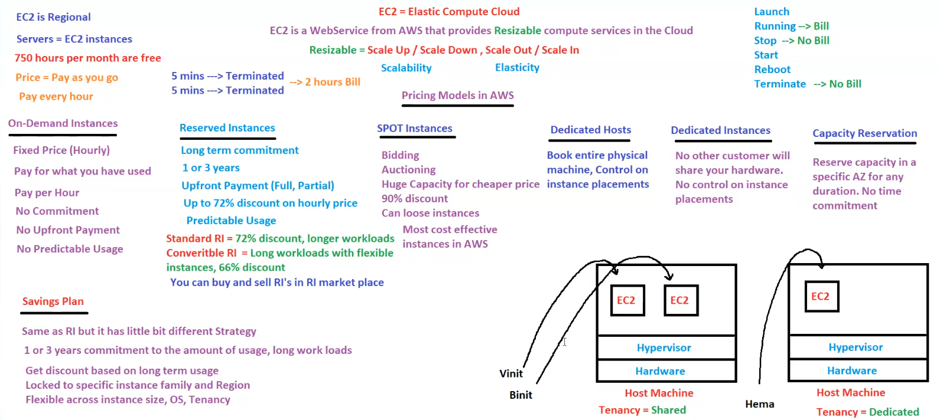

**Amazon EC2 (Elastic Compute Cloud) Overview**

**1. What is EC2?**

* **EC2 = Elastic Compute Cloud**
* **A web service from AWS** that provides **resizable** compute services in the cloud.
* **Resizable**:
  + **Scale Up / Scale Down**
  + **Scale Out / Scale In**
* **Key Features**:
  + **Scalability** – Adjust resources as needed.
  + **Elasticity** – Dynamically adapt to changing demands.

**2. EC2 Billing & Pricing**

* **EC2 is Regional** – Instances are launched within a specific AWS region.
* **750 hours per month free** (AWS Free Tier).
* **Pricing Model**: **Pay as you go** (billed per hour or per second).
* **Billing Rules**:
  + **Launch** → Instance starts running (Billing starts).
  + **Running** → Billed continuously.
  + **Stop** → No billing for compute (EBS storage charges apply).
  + **Terminate** → No billing at all.
  + **Reboot** → No additional charge.
* **Minimum Billing Duration**:
  + If an instance runs for **5 minutes**, it gets **terminated automatically**.
  + Some cases → **Minimum billing is 2 hours**.

**3. EC2 Pricing Models**

AWS provides different pricing models for different use cases:

**A. On-Demand Instances**

* **Fixed price (hourly/per second)**.
* **Pay only for what you use**.
* **No upfront cost** and **no long-term commitment**.
* Best for **short-term, unpredictable workloads**.
* **No predictable usage** → Higher cost compared to reserved instances.

**B. Reserved Instances (RI)**

* **Long-term commitment** (1 or 3 years).
* **Upfront Payment Options**:
  + Full
  + Partial
* **Discounts**:
  + **Up to 72%** discount on hourly price.
* **Predictable Usage** → Ideal for steady workloads.
* **Types**:
  + **Standard RI** – 72% discount for long-term workloads.
  + **Convertible RI** – Flexible instance types, **66% discount**.
* **Resale Option**: Can be **bought and sold in the RI marketplace**.

**C. Spot Instances**

* **Bidding-based pricing** (auction model).
* **Huge cost savings (up to 90%)** compared to On-Demand.
* **Highly cost-effective**, but:
  + **Can lose instances anytime** (AWS can reclaim them).
  + **Best for fault-tolerant and batch workloads**.

**D. Dedicated Hosts**

* **Book an entire physical machine**.
* Provides **control over instance placement**.
* Ideal for regulatory or compliance needs.

**E. Dedicated Instances**

* **No other customer shares the hardware**.
* **No control over instance placement** (unlike Dedicated Hosts).
* Best for **workloads requiring full isolation**.

**F. Capacity Reservation**

* **Reserve capacity in a specific Availability Zone (AZ)**.
* **No time commitment**.
* Useful for **ensuring capacity availability for critical workloads**.

**4. Savings Plan (Alternative to RI)**

* Similar to **Reserved Instances** but **more flexible**.
* **Commitment for 1 or 3 years** based on the amount of usage.
* **Discounts based on long-term usage**.
* **Differences from RI**:
  + Not locked to a specific instance size or OS.
  + More **flexible** across **instance families** and **regions**.
  + Suitable for **long workloads**.

**5. EC2 Tenancy Models**

* **Shared Tenancy (Default)**
  + Multiple customers share the same physical host.
  + **Example**: **Vinit, Binit (Shared Host Machine)**.
* **Dedicated Tenancy**
  + Only one customer uses the hardware.
  + **Example**: **Hema (Dedicated Host Machine)**.

**6. EC2 Instance Lifecycle**

1. **Launch** – Start an EC2 instance.
2. **Running** – Active, and being billed.
3. **Stop** – Instance is halted, no billing for compute.
4. **Reboot** – Restarts the instance without additional cost.
5. **Terminate** – Instance is deleted, no further billing.

**7. Summary**

* **EC2 is AWS's scalable compute service**, offering **multiple pricing options**.
* **Billing follows a "pay-as-you-go" model** with different pricing structures.
* **Reserved Instances and Savings Plans** offer major discounts for long-term commitments.
* **Spot Instances** are the **cheapest** but can be interrupted.
* **Dedicated Hosts and Instances** offer full hardware isolation.
* **Capacity Reservations** ensure available compute power in specific regions.

## EC2 Families & Instance Types

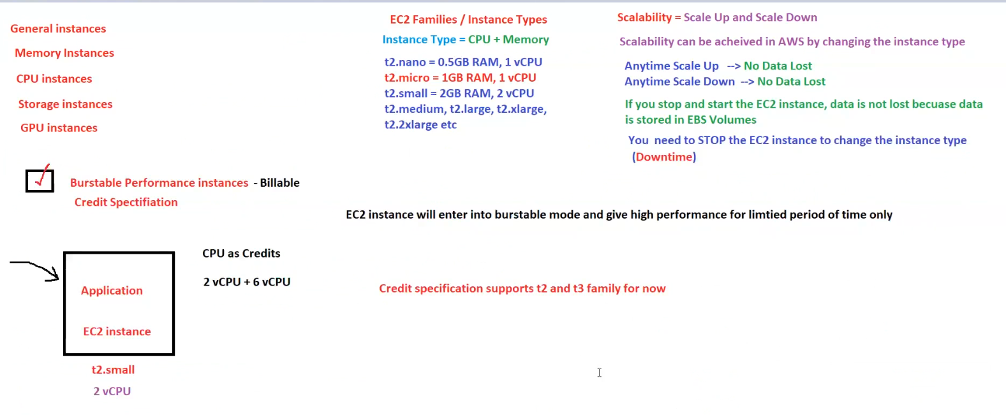

**AWS EC2 Families, Instance Types & Burstable Performance Instances**

**1. EC2 Instance Categories**

AWS EC2 instances are classified into different types based on usage:

* **General Instances** – Balanced compute and memory.
* **Memory Instances** – Optimized for applications requiring high memory.
* **CPU Instances** – Optimized for compute-heavy applications.
* **Storage Instances** – Designed for high disk throughput.
* **GPU Instances** – Used for graphics-intensive workloads and machine learning.

**2. EC2 Families & Instance Types**

Each instance type consists of **CPU + Memory** specifications:

| **Instance Type** | **RAM** | **vCPU** |
| --- | --- | --- |
| **t2.nano** | 0.5 GB | 1 vCPU |
| **t2.micro** | 1 GB | 1 vCPU |
| **t2.small** | 2 GB | 2 vCPU |
| **t2.medium** | Varies | Varies |
| **t2.large, t2.xlarge, t2.2xlarge** | Higher RAM | More vCPUs |

**3. Scalability in EC2**

EC2 supports **scaling up and down** by changing instance types.

* **Scale Up** → **No Data Loss**
* **Scale Down** → **No Data Loss**
* **Data is stored in EBS Volumes** – Restarting does not lead to data loss.
* **Instance Type Change**:
  + You **must stop the EC2 instance** before changing its type.
  + **Downtime is required**.

**4. Burstable Performance Instances**

**What are Burstable Instances?**

* **Billable CPU Credit Specification** for workloads that require **short bursts of high performance**.
* EC2 instances **enter burstable mode** and provide **high performance for a limited time**.

**How Burstable CPU Works?**

* Uses **CPU as Credits**.
* Example:
  + **t2.small** instance with **2 vCPU**.
  + Burstable mode allows up to **6 vCPUs** temporarily.
* **Credit Accumulation**:
  + CPU credits accumulate when the instance is **idle**.
  + High CPU usage consumes accumulated credits.

**Supported EC2 Families**

* **t2 and t3 instance families** support CPU credit specification.

**5. Summary**

* EC2 offers various **instance families** optimized for **different workloads**.
* **Scalability** allows instance type modification but requires **downtime**.
* **Burstable Performance Instances** use **CPU credits** for temporary high-performance bursts.
* **t2 and t3 instances** support CPU credit-based bursting.

## Volumes in EC2

**AWS EC2 Storage: EBS vs Instance Store Volumes**

**1. EBS (Elastic Block Store) Volumes**

* **Persistent Storage / Permanent**
* **If EC2 is stopped and restarted, data is NOT lost.**
* **Maximum EBS Volume Size** = **16TB**
* **EBS volumes are billable** (charged based on size and performance).
* **Rebooting an instance does NOT cause data loss.**

**Types of EBS Volumes**

1. **General Purpose (gp2, gp3)**
   * **SSD storage** for general workloads.
   * **gp2 (Older Standard)**
   * **gp3 (Latest, More Configurable Performance)**
2. **Provisioned IOPS (io1, io2)**
   * **SSD storage** for high-performance applications.
   * **Supports configurable IOPS (faster read/write speeds).**
   * **io2 supports up to 64TB storage.**
3. **Throughput Optimized (st1)**
   * **HDD storage** for frequently accessed large data.
   * **More cost-effective than SSD.**
4. **Cold Storage (sc1)**
   * **HDD storage for infrequent access.**
   * **Cheaper than st1 but lower performance.**
5. **Magnetic (standard)**
   * **Old-generation HDD storage.**
   * **Slower performance, rarely used.**

**Key EBS Features**

* **SSD is faster, HDD is slower.**
* **IOPS (Input/Output Per Second)** determines performance.
* **Default Volume Types**:
  + **Windows** → gp2
  + **Linux** → gp3
* **Configurable IOPS for io1, io2, gp3.**
* **Higher IOPS = Better performance but higher cost.**
* **gp2 has fixed IOPS (3 IOPS per GB).**
* **Root Volume Supported Types**: gp2, gp3, io1, io2, standard
* **Root Volume Does NOT Support**: st1, sc1
* **Additional Volumes Can Be Any Type.**
* **Multi-Attach Feature**:
  + io1 and io2 volumes can be attached to **multiple EC2 instances**.
  + **Supports up to 16 EC2 instances at a time.**

**2. Instance Store Volumes (ISV)**

* **Not Persistent / Temporary Storage**
* **If EC2 is stopped and restarted, data is LOST.**
* **Instance Store Volumes are FREE.**
* **Also known as Ephemeral Storage.**

**Key Features**

* **Root Volume Behavior:**
  + If an EC2 instance is **terminated**, the **root volume is deleted** because "Delete on Termination" is **enabled by default**.
* **Additional Volume Behavior:**
  + If an EC2 instance is **terminated**, additional volumes **are NOT deleted** because "Delete on Termination" is **disabled by default**.

**Instance Store Volume Availability**

* **Typically available in larger instance types.**
* **AWS automatically provides ISV for free if the instance supports it.**

**Using ISV as a Root Volume**

* **EC2 instances can have ISV as their root volume.**
* **However, such EC2 instances cannot be stopped—only terminated.**

**3. Key Differences Between EBS and ISV**

| **Feature** | **EBS (Elastic Block Store)** | **Instance Store Volumes (ISV)** |
| --- | --- | --- |
| **Persistence** | Data is **persistent** | Data is **lost** when the instance stops |
| **Reboot Impact** | **No Data Loss** | **Data Loss** |
| **Billing** | **Charged per GB** | **Free** |
| **Size Limit** | **Up to 16TB** | **Varies** (depends on instance type) |
| **Performance** | Configurable IOPS | High-speed but **not configurable** |
| **Attachable?** | Can be attached/detached from instances | Tied to a specific instance |
| **Multi-Attach?** | io1/io2 can be attached to 16 EC2 instances | **Not possible** |

**4. Summary**

* **EBS is persistent and billable, ISV is temporary and free.**
* **Stopping an EC2 instance does not affect EBS data but will erase ISV data.**
* **Instance store volumes are automatically attached to large EC2 instances.**
* **EBS supports SSD (gp2, gp3, io1, io2) and HDD (st1, sc1, magnetic).**
* **Multi-attach is possible for io1/io2 but not for other EBS types.**

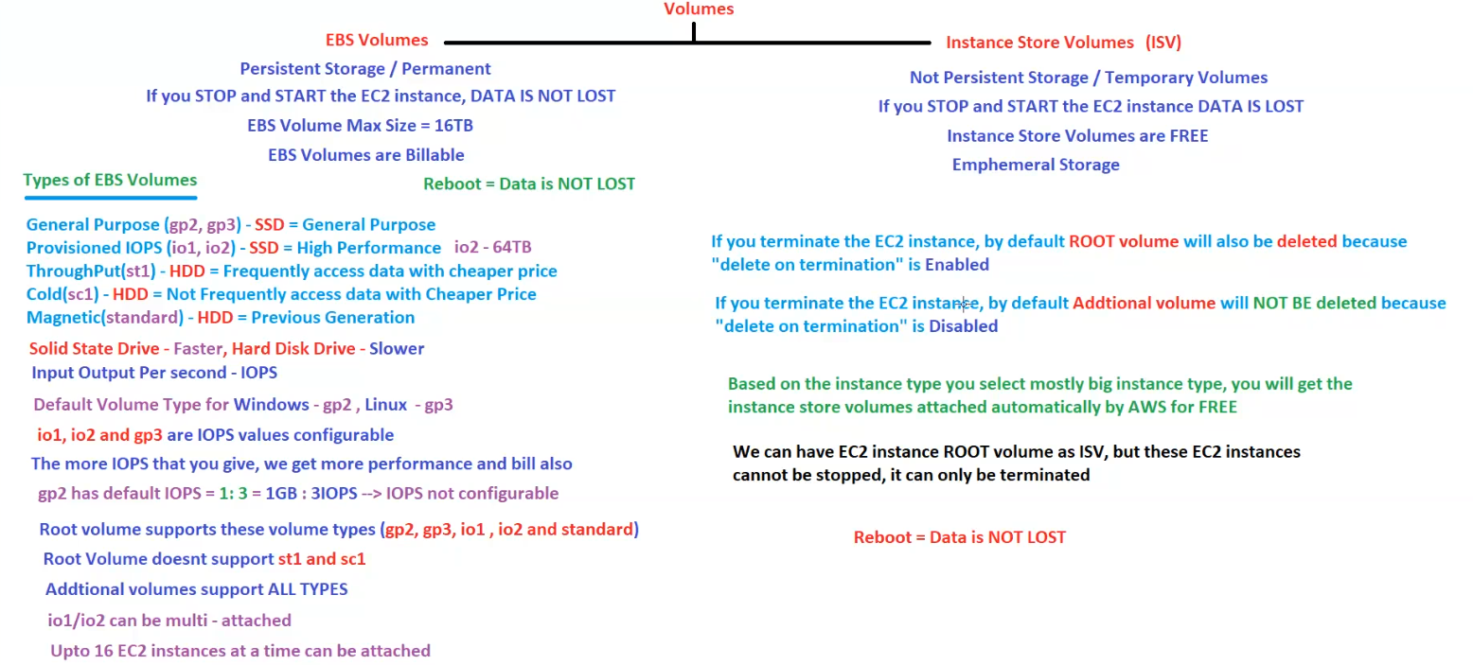

## EBS

**AWS EC2 Storage: EBS vs ISV and Instance Status Checks**

**1. EBS (Elastic Block Store)**

* **Persistent Storage (Centralized)**
* **Data is NOT lost** if the EC2 instance is **stopped and started**.
* **Rebooting does NOT cause data loss**.
* **Terminate = Data is LOST**.

**Behavior**

* **Stop & Start (Jump)** → **Data is not lost**.
* **Reboot (No Jump)** → **Data is not lost**.
* **Terminate** → **Data is lost**.

**2. Instance Store Volumes (ISV)**

* **Temporary Storage (Local)**
* **Data is LOST** if the EC2 instance is **stopped and started**.
* **Rebooting does NOT cause data loss**.
* **Terminate = Data is LOST**.

**Behavior**

* **Stop & Start (Jump)** → **Data is lost**.
* **Reboot (No Jump)** → **Data is not lost**.
* **Terminate** → **Data is lost**.

**Key Points**

* **ISV provides high-performance hardware disks but comes with a risk of data loss.**
* **Customers need to manage data storage inside ISV.**
* **ISV is free but available only on specific instance types.**

**3. Instance Status Checks**

AWS performs **two types of status checks** on EC2 instances:

1. **Instance Status Check** = **Hardware issues**.
2. **System Status Check** = **Software/OS issues**.

**Status Check Outcomes**

| **Status Check** | **Status** | **Action Required** |
| --- | --- | --- |
| **2/2 Passed** | ✅ Can log in | No issue |
| **1/2 Passed** | ❌ Cannot log in | Stop and Start instance |
| **0/2 Passed** | ❌ Cannot log in | Stop and Start instance |

**Solution:**

* If an instance fails **1/2 or 0/2 status checks**, **DO NOT terminate** it.
* **Simply STOP and START the instance** to resolve the issue.

**4. EBS vs ISV - Key Differences**

| **Feature** | **EBS (Elastic Block Store)** | **Instance Store Volumes (ISV)** |
| --- | --- | --- |
| **Persistence** | **Data is retained** after stop/start | **Data is lost** after stop/start |
| **Performance** | **Good but limited** | **High performance** |
| **Billing** | **Charged per GB** | **Free** |
| **Reboot Effect** | **Data is not lost** | **Data is not lost** |
| **Stop & Start Effect** | **Data is retained** | **Data is lost** |
| **Termination Effect** | **Data is lost** | **Data is lost** |

**5. EC2 Instance Lifecycle States**

EC2 instances go through **six different states**:

1. **Launch** → **Pending / Running**
2. **Stop** → **Stopping / Stopped**
3. **Terminate** → **Shutting Down / Terminated**
4. **Reboot** → **No Change / Running**

**6. Summary**

* **EBS = Persistent storage** → Best for long-term use.
* **ISV = High-performance but temporary** → Data is lost if stopped.
* **Always stop and start EC2 instances if status checks fail**.
* **Do not terminate instances immediately if login issues occur**.
* **Understand EC2 instance lifecycle states to manage workloads effectively.**

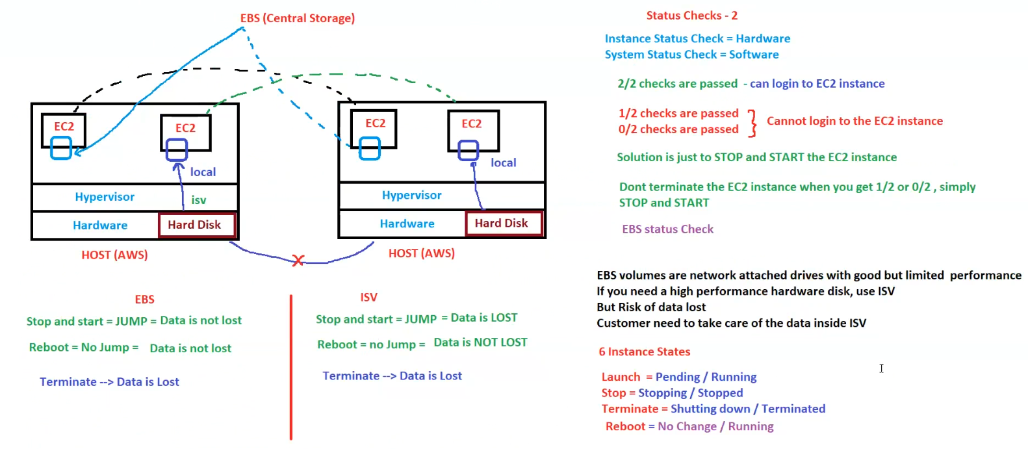

## EBS Snapshots

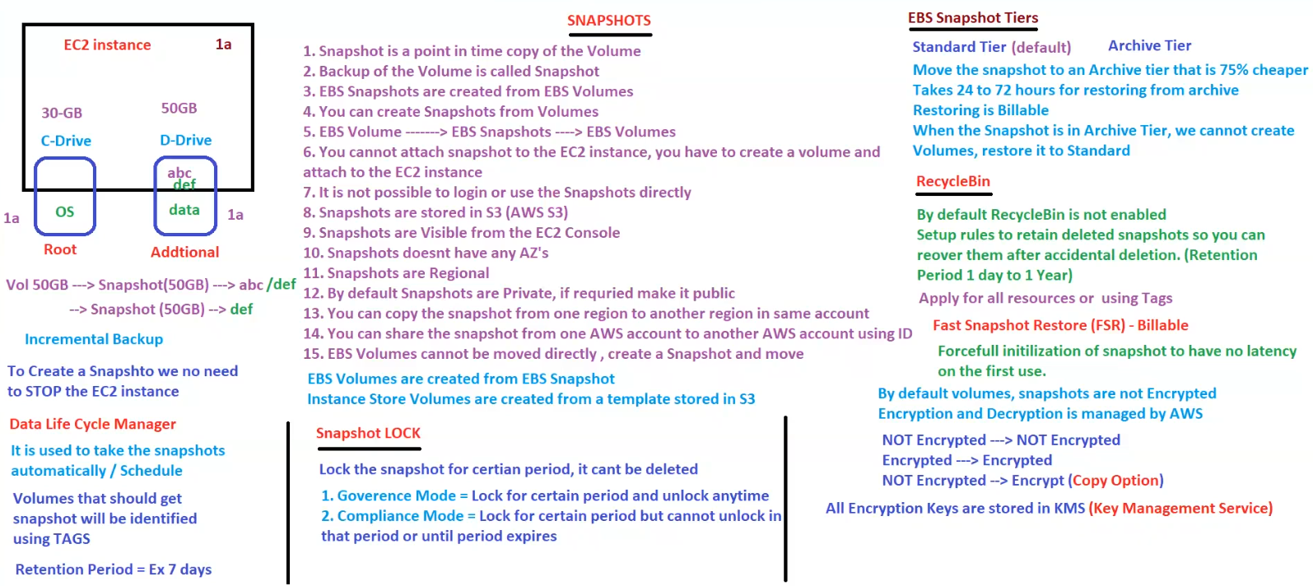

**AWS EBS Snapshots - Backup & Recovery**

**1. What is a Snapshot?**

1. A **snapshot is a point-in-time copy** of an EBS volume.
2. It acts as a **backup of the volume**.
3. **EBS Snapshots** are created **from EBS Volumes**.
4. Snapshots are **stored in AWS S3** (but are not user-accessible in S3).
5. **Snapshots are regional** (can be copied across regions).
6. **Snapshots do not have an Availability Zone (AZ)**.
7. Snapshots **are visible from the AWS EC2 Console**.
8. **Snapshots are private by default** (can be made public if needed).
9. **Snapshots cannot be attached to EC2 directly**; you must **create a volume from a snapshot** and then attach the volume to an instance.
10. **EBS volumes cannot be moved directly** → You must create a **snapshot first** and then move.

**2. How Snapshots Work?**

* **Incremental Backup**:
  + The **first snapshot** captures the **entire volume**.
  + Subsequent snapshots only store **changed data**.
* **Snapshots can be taken without stopping the EC2 instance**.
* **EBS Volumes are created from EBS Snapshots**.
* **Instance Store Volumes (ISV) are created from templates stored in S3**.

**3. Snapshot Management**

**A. Data Lifecycle Manager (DLM)**

* **Automates snapshot creation** on a schedule.
* **Uses AWS Tags** to identify which volumes need snapshots.
* **Retention Period Example**: 7 days.

**B. Snapshot Lock**

* **Locks the snapshot for a certain period, preventing deletion**.
* **Two Modes**:
  1. **Governance Mode** → Lock the snapshot but **can unlock anytime**.
  2. **Compliance Mode** → Lock for a specific period **without an unlock option**.

**4. EBS Snapshot Tiers**

**A. Standard Tier (Default)**

* Default snapshot storage.
* Snapshots can be **restored anytime**.

**B. Archive Tier**

* **75% cheaper** than Standard Tier.
* **Takes 24 to 72 hours** to restore from archive.
* **Restoring is billable**.
* **Cannot create a volume from an archived snapshot**; you must first restore it to Standard.

**5. Recycle Bin for Snapshots**

* **By default, Recycle Bin is NOT enabled**.
* **Allows recovery of accidentally deleted snapshots**.
* **Retention Period**: **1 day to 1 year**.
* Can apply rules to **all resources or specific ones using Tags**.

**6. Fast Snapshot Restore (FSR)**

* **Billable feature**.
* **Pre-warms snapshots to reduce latency** on first use.

**7. Encryption & Security**

* **By default, snapshots are NOT encrypted**.
* **Encryption & Decryption are managed by AWS**.
* **Encryption Key Storage**: **AWS KMS (Key Management Service)**.
* **Encryption Behavior**:
  + **Not Encrypted → Not Encrypted**.
  + **Encrypted → Encrypted**.
  + **Not Encrypted → Encrypt (via Copy Option)**.

**8. Key Takeaways**

* **EBS Snapshots provide incremental backups without downtime**.
* **Stored in S3 but not directly accessible**.
* **Snapshots can be copied across AWS regions**.
* **Recycle Bin prevents accidental snapshot deletion**.
* **Archive Tier offers cost savings but requires restore time**.
* **Encryption and security are handled by AWS KMS**.

## How to move a volume from one AZ to another AZ

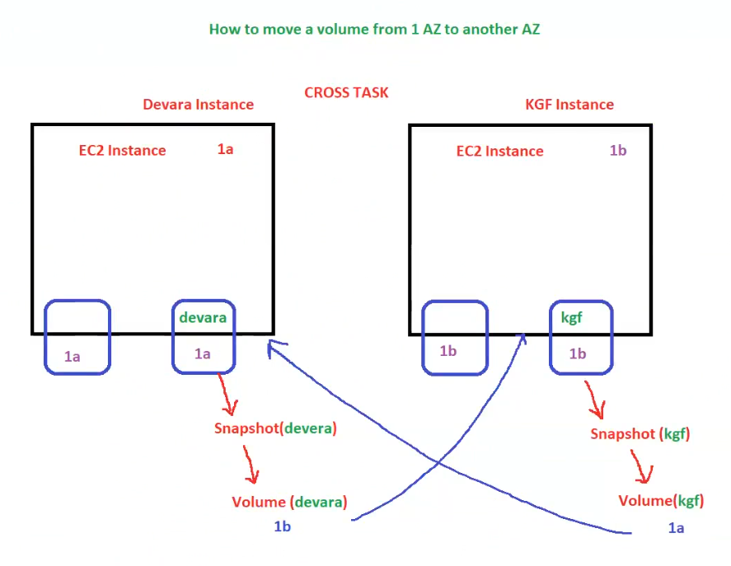

**How to Move an EBS Volume from One Availability Zone (AZ) to Another AZ**

**Scenario**

You have two EC2 instances in different Availability Zones (AZs):

1. **Devara Instance** in **AZ 1a**
2. **KGF Instance** in **AZ 1b**

You want to **move an EBS volume from one AZ to another AZ**.

**Steps to Move a Volume Across AZs**

Since EBS volumes are **tied to a specific AZ**, they **cannot be moved directly**.  
The correct way is to **create a snapshot and restore it in the target AZ**.

**Step-by-Step Process**

**1. Moving "devara" Volume from AZ 1a to AZ 1b**

1. **Create a snapshot of the existing volume** (devara in AZ 1a).
2. **Create a new volume from the snapshot in the target AZ** (AZ 1b).
3. **Attach the new volume to the target EC2 instance** in AZ 1b.
4. **Detach and delete the old volume (optional)**.

**2. Moving "kgf" Volume from AZ 1b to AZ 1a**

1. **Create a snapshot of the existing volume** (kgf in AZ 1b).
2. **Create a new volume from the snapshot in the target AZ** (AZ 1a).
3. **Attach the new volume to the target EC2 instance** in AZ 1a.
4. **Detach and delete the old volume (optional)**.

**AWS CLI Commands**

**Step 1: Create a Snapshot**

aws ec2 create-snapshot --volume-id vol-xxxxxxxxxxxxxxxxx --description "Snapshot for AZ migration"

**Step 2: Create a New Volume in the Target AZ**

aws ec2 create-volume --snapshot-id snap-xxxxxxxxxxxxxxxxx --availability-zone us-east-1b

**Step 3: Attach the Volume to the Target Instance**

aws ec2 attach-volume --volume-id vol-yyyyyyyyyyyyyyyyy --instance-id i-zzzzzzzzzzzzzzzzz --device /dev/xvdf

**Key Considerations**

* **You cannot directly move an EBS volume across AZs**.
* **Snapshots are stored in Amazon S3 but are not directly accessible**.
* **Restoring from a snapshot to a new volume is the recommended method**.
* **Ensure the instance type supports the new volume before attaching it**.
* **Data integrity should be verified after attaching the new volume**.

**Summary**

* **EBS volumes are AZ-specific** and **cannot be moved directly**.
* **Use snapshots to migrate a volume from one AZ to another**.
* **Restore the snapshot as a new volume in the target AZ**.
* **Use AWS CLI or AWS Console to perform this migration**.

## Images

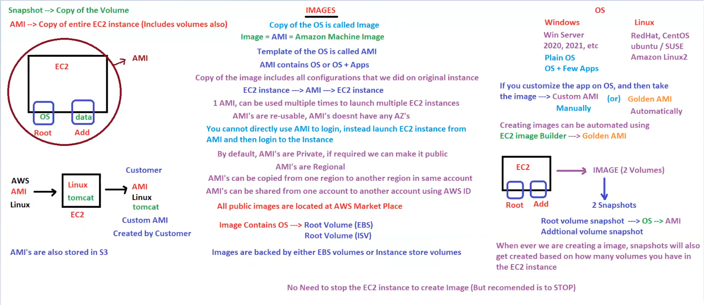

**AWS AMI (Amazon Machine Image) - EC2 Image Management**

**1. What is an AMI?**

* **AMI = Amazon Machine Image** → A **template** that contains the OS and applications needed to launch EC2 instances.
* **Snapshot vs. AMI**:
  + **Snapshot** → Backup of an EBS **volume**.
  + **AMI** → Backup of an **entire EC2 instance** (includes OS, applications, and configurations).

**2. How AMI Works**

* **AMI contains**:
  + **OS only** (Plain AMI)
  + **OS + Applications** (Custom AMI)
* **Process**:
  + **Create an EC2 instance**.
  + **Customize the OS/applications as needed**.
  + **Create an AMI** from the instance.
  + **Use the AMI to launch multiple EC2 instances** with the same configuration.
* **1 AMI can be used multiple times to launch multiple EC2 instances**.
* **AMIs are reusable and do not belong to a specific Availability Zone (AZ).**

**3. AMI Characteristics**

* **You cannot directly log into an AMI**.
  + Instead, **launch an EC2 instance from the AMI** and then access it.
* **By default, AMIs are Private**.
  + Can be made **public** if needed.
* **AMIs are Regional**.
  + Can be **copied from one region to another**.
  + Can be **shared between AWS accounts** using AWS Account IDs.
* **All public AMIs are available in AWS Marketplace**.

**4. AMI Storage**

* **AMI consists of**:
  + **Root Volume (EBS or Instance Store)**
  + **Additional Volumes (if any)**
* **EBS-backed AMIs**:
  + AMI is stored in **EBS snapshots** (persisted in S3).
  + **Supports stop, restart, and terminate actions**.
* **Instance Store-backed AMIs**:
  + AMI is stored in **Instance Store volumes**.
  + **Data is lost if the instance is stopped**.

**5. Types of AMIs**

1. **AWS AMI** – Default AMIs provided by AWS (Linux, Windows, etc.).
2. **Custom AMI** – Created by a customer after modifying the OS/applications.
3. **Golden AMI** – A pre-configured, fully secured, and optimized AMI, usually created using **EC2 Image Builder**.

**6. Creating an AMI**

* **You don’t need to stop the EC2 instance to create an AMI**.
  + However, it is **recommended to stop the instance** to ensure data consistency.
* **When an AMI is created, snapshots are also generated** based on the number of volumes attached to the EC2 instance.

**7. AMI Creation Workflow**

1. **Launch an EC2 instance**.
2. **Customize it** (install software, update configurations, etc.).
3. **Create an AMI** (this generates snapshots).
4. **Launch new EC2 instances from the AMI**.

**AMI Creation via AWS CLI**

aws ec2 create-image --instance-id i-xxxxxxxxxxxxxxxxx --name "MyCustomAMI" --no-reboot

**8. Summary**

* **AMI = A template for launching EC2 instances**.
* **Can be reused multiple times**.
* **Stored in S3 as EBS snapshots**.
* **Can be copied across regions and shared between AWS accounts**.
* **Golden AMIs help standardize deployments**.

## Key Pair

**AWS EC2 Key Pairs & Secure Access**

**1. What is a Key Pair?**

* A **Key Pair** is used to **retrieve the password of an EC2 instance** and authenticate access.
* A **Key Pair consists of**:
  + **Public Key** (Stored in AWS).
  + **Private Key (.pem file)** (Held by the customer).
* **By default, AWS does not provide a key pair**, so you must create one.
* The key pair file has a **.pem** extension and is also called a **PEM file**.

**2. Key Pair Usage & Rules**

* **A single Key Pair can be attached to multiple EC2 instances**.
* **An EC2 instance can have only ONE key pair attached at a time**.
* **Once a key pair is attached and the instance is launched, it cannot be changed**.
* **If the PEM file is lost, it cannot be recovered** → Keep it secure.
* **Every EC2 instance has a unique password**.
* **Retrieving the password using the same PEM file will always return the same password**.

**3. AWS Key Pair Security**

* **AWS stores the Public Key**.
* **Customers hold the Private Key (.pem file)**.
* If the **private key (.pem file) is lost**, you will **lose access to the instance**.

**4. How to Connect to an EC2 Instance**

**Windows EC2 Instance**

* **Protocol**: **RDP (Remote Desktop Protocol)**
* **Port Number**: **3389**
* **Client Tool**: **Remote Desktop Connection (RDP Client)**

**Linux EC2 Instance**

* **Protocol**: **SSH (Secure Shell)**
* **Port Number**: **22**
* **Client Tools**: **Putty / MobaXterm**

**Important Note for Linux Instances**

* **Putty does not support .pem files directly**.
* You must **convert the .pem file to a .ppk file** using **PuttyGen**.

**5. Key Pair Usage in Teams**

* Different teams can have **separate key pairs**:
  + **DevOps** uses devops.pem.
  + **Developers** use developer.pem.
* If a wrong key pair is used, **access to the instance will be denied**.

**6. Summary**

* **Key Pairs authenticate access to EC2 instances**.
* **One key pair per EC2 instance (cannot change after launch)**.
* **Keep the PEM file secure, as losing it means losing access**.
* **Use RDP for Windows and SSH for Linux**.
* **Convert PEM to PPK for Putty users**.

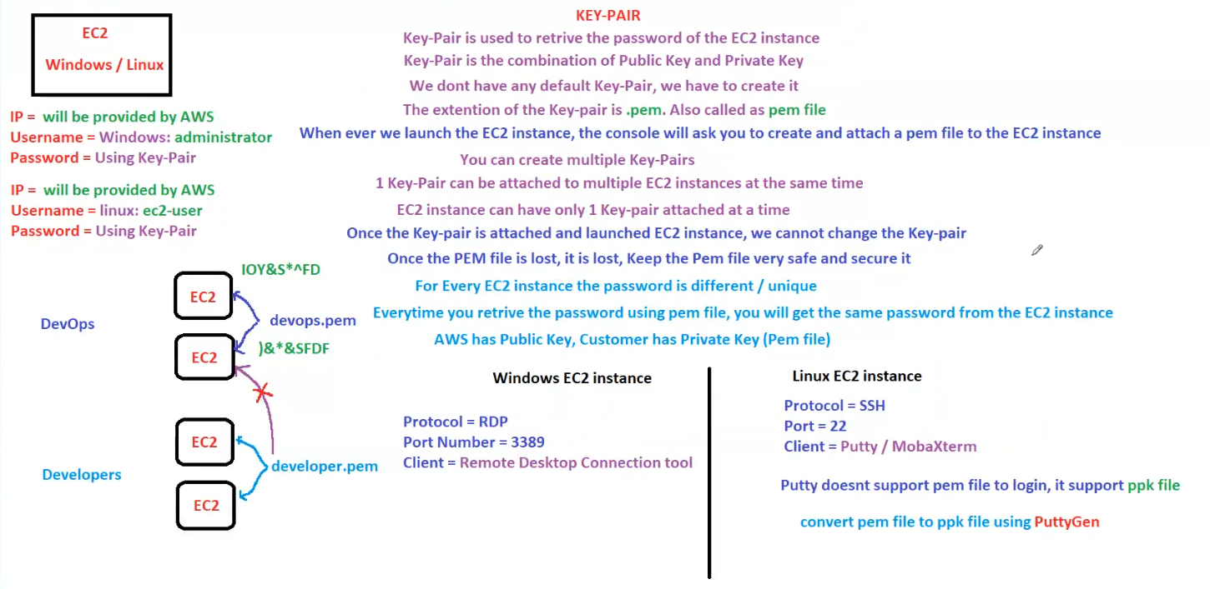

## EC2 Authentication & Active Directory Integration

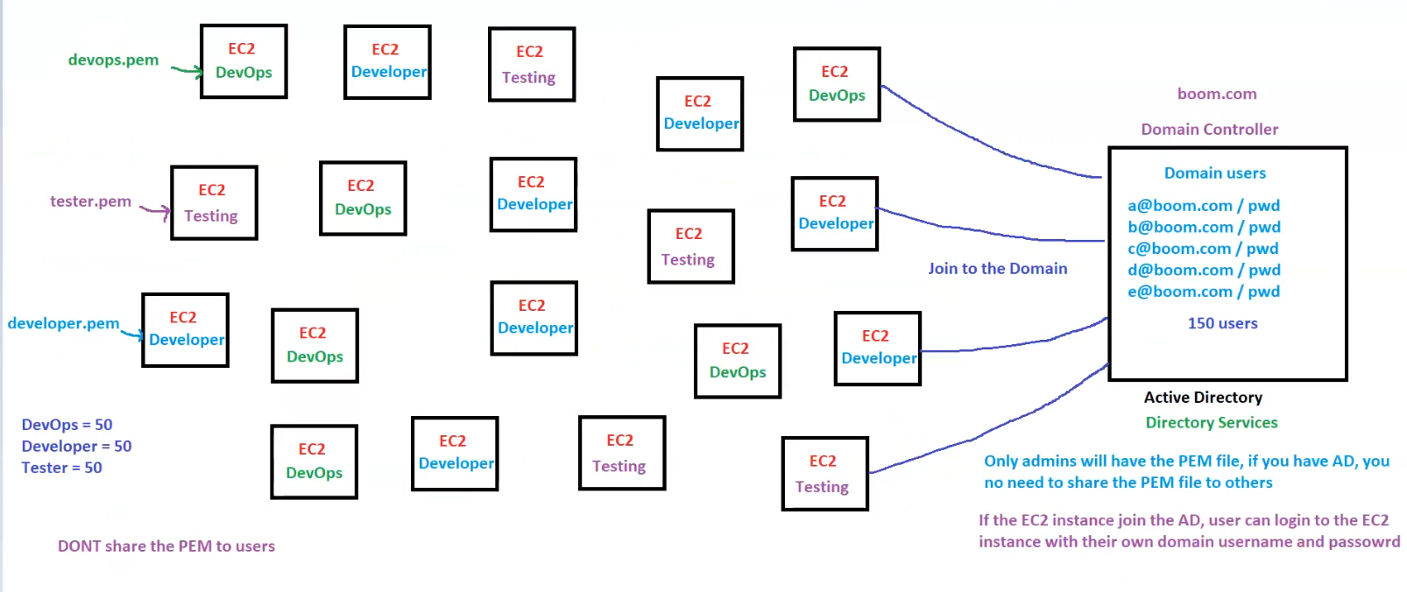

**AWS EC2 Authentication & Active Directory Integration**

**1. EC2 Authentication with Key Pairs**

* **Key Pairs (.pem files) are used to authenticate EC2 instances**.
* **Different teams have separate key pairs**:
  + **DevOps** → devops.pem
  + **Developers** → developer.pem
  + **Testers** → tester.pem
* **Total EC2 instances:**
  + **50 DevOps**
  + **50 Developers**
  + **50 Testers**
* **Do NOT share the PEM file with users** for security reasons.

**2. Active Directory (AD) Integration**

* **Domain Controller: boom.com**
* **Active Directory (AD) Manages User Authentication**.
* **150 domain users** with credentials like:
  + a@boom.com / password
  + b@boom.com / password
  + c@boom.com / password
* **EC2 instances can be joined to the Active Directory (AD)**.

**3. How AD Integration Works**

* **EC2 instances join the Active Directory domain**.
* **Users authenticate using their domain credentials** instead of key pairs.
* **Admins retain control over PEM files**, but they are **not needed for domain-authenticated users**.
* **Once an EC2 instance is in AD, users log in with their domain usernames and passwords**.

**4. Benefits of Using AD for Authentication**

✅ **No need to share private PEM files**.  
✅ **Users can log in with their own domain credentials**.  
✅ **Centralized user management with AD**.  
✅ **Easier to manage access for large teams**.

**5. Key Takeaways**

* **Admins keep PEM files, but general users log in via AD credentials**.
* **EC2 instances can be domain-joined for authentication security**.
* **Active Directory eliminates the need for sharing private key files**.
* **Users authenticate using their corporate credentials (boom.com domain)**.

## EC2 Placement Groups

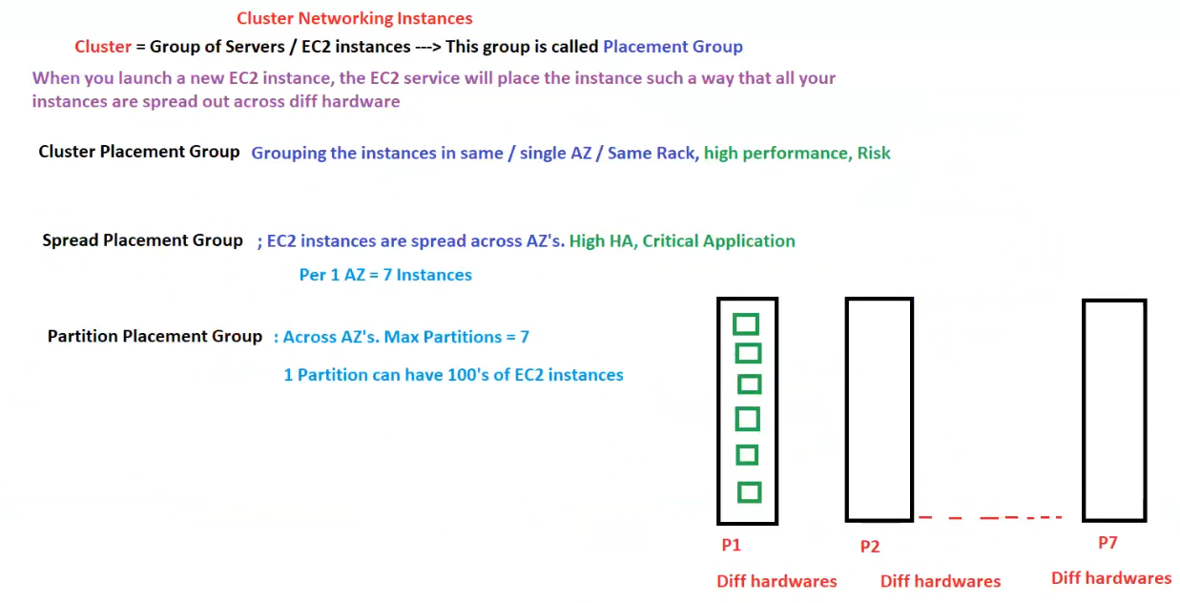

**AWS EC2 Placement Groups**

**1. What is a Placement Group?**

* A **Placement Group** is a **logical grouping of EC2 instances** that influences **how instances are placed on AWS hardware**.
* **Purpose**: To optimize **network performance, availability, or fault tolerance**.

**2. Types of Placement Groups**

**A. Cluster Placement Group**

* **Instances are placed in the same AZ, same rack, or close proximity**.
* **Optimized for high-performance computing (HPC) and low-latency networking**.
* **Key Use Case**: Workloads requiring **high network throughput** and **low latency**.
* **Risk**: If the rack fails, all instances in the group may fail.

**B. Spread Placement Group**

* **Instances are distributed across multiple Availability Zones (AZs)**.
* **Ensures high availability (HA) and fault tolerance**.
* **Best for critical applications** where each instance needs to be on a separate rack.
* **Limit**: **Maximum of 7 instances per AZ**.
* **Key Use Case**: **Highly available applications with low instance count**.

**C. Partition Placement Group**

* **Instances are divided into logical partitions** across different racks and AZs.
* **Each partition contains multiple EC2 instances, reducing risk**.
* **Max partitions = 7**.
* **1 partition can have hundreds of EC2 instances**.
* **Key Use Case**: Large **distributed and big data workloads (e.g., Hadoop, Cassandra, HDFS)**.

**3. Comparison of Placement Groups**

| **Placement Group Type** | **Instances Placement** | **Use Case** | **Risk Level** |
| --- | --- | --- | --- |
| **Cluster** | Same AZ, same rack | High-performance, low latency | High risk (rack failure affects all) |
| **Spread** | Distributed across AZs | Critical applications | Low risk (each instance on a separate rack) |
| **Partition** | Grouped into partitions across different hardware | Large-scale, fault-tolerant workloads | Medium risk (failure affects one partition only) |

**4. Key Takeaways**

✅ **Cluster Placement Group** → Best for **high-performance workloads** but has **high failure risk**.  
✅ **Spread Placement Group** → Best for **high availability** (max **7 instances per AZ**).  
✅ **Partition Placement Group** → Best for **large-scale distributed systems**.

## EC2 Security Groups & Network Access Control

**AWS EC2 Security Groups & Network Access Control**

**1. What is a Security Group (SG)?**

* **A Security Group acts as a virtual firewall** that controls **inbound and outbound traffic** for EC2 instances.
* **SGs can be attached to multiple EC2 instances**.
* **One EC2 instance can have multiple Security Groups**.

**2. Security Group Rules**

* **Inbound Rule**: Controls **incoming traffic** to the EC2 instance.
* **Outbound Rule**: Controls **outgoing traffic** from the EC2 instance.

| **Default Settings** | **Behavior** |
| --- | --- |
| Inbound Rules | **DENY ALL** (No traffic is allowed unless explicitly allowed) |
| Outbound Rules | **ALLOW ALL** (All traffic is allowed by default) |

* **You cannot explicitly DENY traffic in Security Groups** because **inbound rules are DENY by default**.
* **SGs only ALLOW rules**, they do not support explicit **DENY**.

**3. Key Firewall Rules**

✅ **Allow SSH (Port 22)** → Enables SSH access to Linux instances.  
✅ **Allow RDP (Port 3389)** → Enables Remote Desktop access to Windows instances.  
✅ **Allow HTTP (Port 80)** → Enables non-secure website access.  
✅ **Allow HTTPS (Port 443)** → Enables secure website access.

**4. Stateful vs. Stateless**

* **Security Groups are STATEFUL**:
  + If **an inbound rule is allowed**, the corresponding outbound rule is **automatically allowed**.
* **Network ACLs (NACLs) are STATELESS**:
  + **Explicit outbound rules are required** if inbound traffic is allowed.

| **Feature** | **Security Group (SG)** | **Network ACL (NACL)** |
| --- | --- | --- |
| **Type** | Firewall for EC2 | Firewall for entire Subnet |
| **State** | **Stateful** | **Stateless** |
| **Inbound Default** | **DENY ALL** | **ALLOW ALL** |
| **Outbound Default** | **ALLOW ALL** | **ALLOW ALL** |
| **Explicit DENY Rule?** | ❌ No | ✅ Yes |

**5. Additional Security Group Considerations**

* **Each EC2 instance must have at least one Security Group attached**.
* **Multiple Security Groups can be assigned to one EC2 instance**.
* **Security Groups are at the EC2 instance level, while NACLs operate at the subnet level**.
* **AWS provides a default Security Group**.
  + If no Security Group is attached, the **default SG is used**.

**6. Summary**

* **Security Groups control traffic at the EC2 level, while NACLs control traffic at the subnet level**.
* **SGs are stateful** → If you allow inbound traffic, the response traffic is automatically allowed.
* **NACLs are stateless** → If inbound is allowed, outbound must be manually allowed.
* **Inbound traffic is denied by default; outbound is allowed by default**.

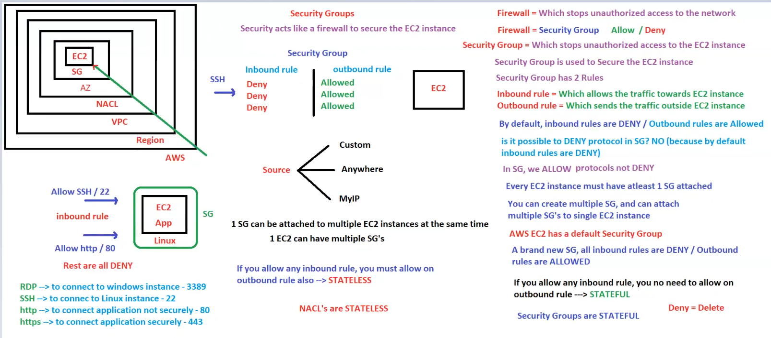

## SG Design for EC2

**AWS Security Group (SG) Design for EC2, Load Balancer & Database**

**1. Overview of Security Groups (SG)**

* **Security Groups (SGs) control inbound and outbound traffic** for EC2, Load Balancers, and Databases.
* **Each EC2 instance must have at least one SG**.
* **Multiple SGs can be attached to a single EC2 instance**.

**2. Security Group Architecture**

**A. Default Security Group (Default-SG)**

* **Applies to general EC2 instances**.
* Can receive traffic from:
  + **Custom IP ranges**
  + **Anywhere (0.0.0.0/0)**
  + **MyIP (specific user-defined IPs)**.

**B. ELB Security Group (ELB-SG)**

* **Applies to Elastic Load Balancer (ELB)**.
* Accepts traffic **via HTTP (80) and HTTPS (443)**.
* **Source**: Public internet (0.0.0.0/0) or specific IPs.

**C. Application Security Group (APP-SG)**

* **Applies to application EC2 instances**.
* Accepts traffic only from **ELB-SG** (ensuring only the load balancer can communicate with the app servers).
* Restricts direct access from the internet.

**D. Database Security Group (DB-SG)**

* **Applies to database instances**.
* Accepts traffic **only from APP-SG** (ensuring only application servers can talk to the database).
* Restricts direct access from ELB or the internet.

**3. Traffic Flow & Security Group Rules**

| **Source** | **Destination** | **Allowed Protocols/Ports** |
| --- | --- | --- |
| **Public (0.0.0.0/0)** | **ELB-SG** | **HTTP (80), HTTPS (443)** |
| **ELB-SG** | **APP-SG (EC2 App Instances)** | **HTTP (80), HTTPS (443)** |
| **APP-SG** | **DB-SG (Database Instances)** | **MySQL (3306), PostgreSQL (5432)** |

**4. Key Security Considerations**

✅ **Layered Security Model** → Only the necessary components communicate.  
✅ **No direct internet access for application and database layers**.  
✅ **Access control follows AWS best practices for security groups**.  
✅ **Traffic is only allowed from specific sources (SG dependencies instead of IP-based access).**

**5. Summary**

* **Use ELB-SG to handle internet traffic securely**.
* **Restrict APP-SG to accept traffic only from ELB-SG**.
* **DB-SG should only accept traffic from APP-SG, never directly from the public**.
* **This layered SG approach ensures high security and controlled access**.

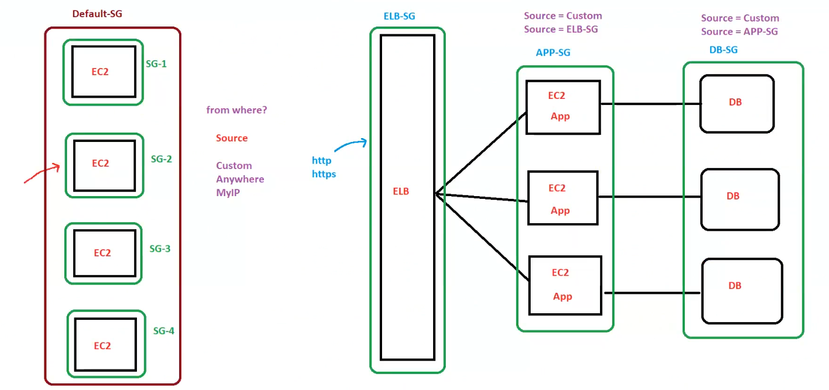

## Network Access Control List (NACL)

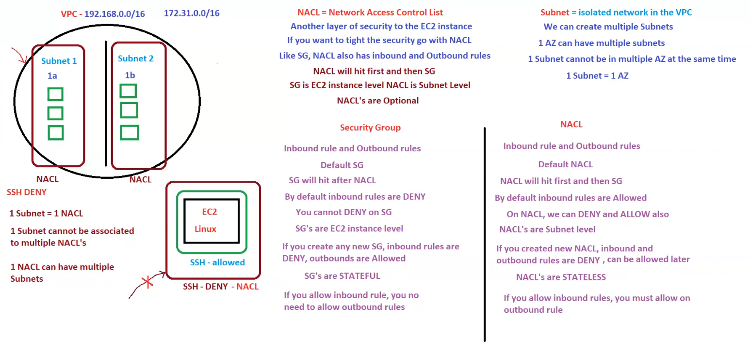**AWS Security: NACL vs. Security Groups (SG) in VPC**

**1. VPC and Subnet Basics**

* **VPC (Virtual Private Cloud) is a logically isolated network**.
* **A VPC contains multiple subnets**.
* **Subnet = Isolated network within the VPC**.
* **One Subnet belongs to only one AZ (Availability Zone)**.
* **One AZ can have multiple subnets**.
* **A Subnet cannot belong to multiple AZs at the same time**.

**2. What is a Network Access Control List (NACL)?**

* **NACL = Network Access Control List** → A **firewall at the subnet level**.
* **Another layer of security for EC2 instances** in a subnet.
* **NACL rules apply to all EC2 instances inside the subnet**.
* **NACLs process traffic before Security Groups**.

**NACL Key Features**

✅ **Applies at the subnet level**.  
✅ **Can ALLOW or DENY traffic** (Unlike Security Groups).  
✅ **Default NACL allows all inbound and outbound traffic**.  
✅ **Custom NACL starts with DENY ALL** (needs explicit allow rules).  
✅ **NACLs are STATELESS** (If inbound is allowed, outbound must also be explicitly allowed).  
✅ **One subnet = One NACL** (A subnet cannot have multiple NACLs).  
✅ **One NACL can be associated with multiple subnets**.

**3. What is a Security Group (SG)?**

* **Security Group is an instance-level firewall**.
* **Applies at the EC2 instance level** (each instance must have at least one SG).
* **Security Groups process traffic after NACLs**.

**SG Key Features**

✅ **Applies at the EC2 instance level**.  
✅ **Only ALLOWS traffic (No explicit DENY rules)**.  
✅ **Default SG denies all inbound but allows all outbound**.  
✅ **Security Groups are STATEFUL** (If inbound is allowed, outbound is automatically allowed).  
✅ **An EC2 instance can have multiple Security Groups**.  
✅ **One Security Group can be attached to multiple EC2 instances**.

**4. Comparison: Security Group vs. NACL**

| **Feature** | **Security Group (SG)** | **Network ACL (NACL)** |
| --- | --- | --- |
| **Applies to** | EC2 Instance Level | Subnet Level |
| **Rules Type** | Only ALLOW (No DENY) | ALLOW and DENY |
| **Default Behavior** | Inbound = DENY, Outbound = ALLOW | Inbound & Outbound = ALLOW (Default NACL) |
| **Statefulness** | **Stateful** (Allowing inbound allows outbound automatically) | **Stateless** (Must explicitly allow outbound if inbound is allowed) |
| **Processing Order** | Processed **after** NACL | Processed **before** Security Groups |
| **Multiple Associations?** | Multiple SGs per instance | 1 NACL per subnet, 1 NACL can have multiple subnets |

**5. Security Flow: NACL vs SG**

1. **NACL processes traffic first (Subnet Level)**.
2. **SG processes traffic next (Instance Level)**.
3. **If NACL blocks traffic, Security Group rules won’t matter**.
4. **If NACL allows traffic, Security Group must also allow it for successful access**.

**6. SSH Deny Example**

* **NACL blocks SSH (Port 22)**, even though **SG allows it**.
* **Traffic is denied at the subnet level, so the instance is unreachable**.

**7. Summary**

* **Use NACLs for subnet-level security** (Optional but useful for extra security layers).
* **Use Security Groups for instance-level security** (Mandatory for EC2 access control).
* **SGs are stateful, while NACLs are stateless**.
* **NACLs allow explicit DENY rules; Security Groups do not**.

## Auto Scaling

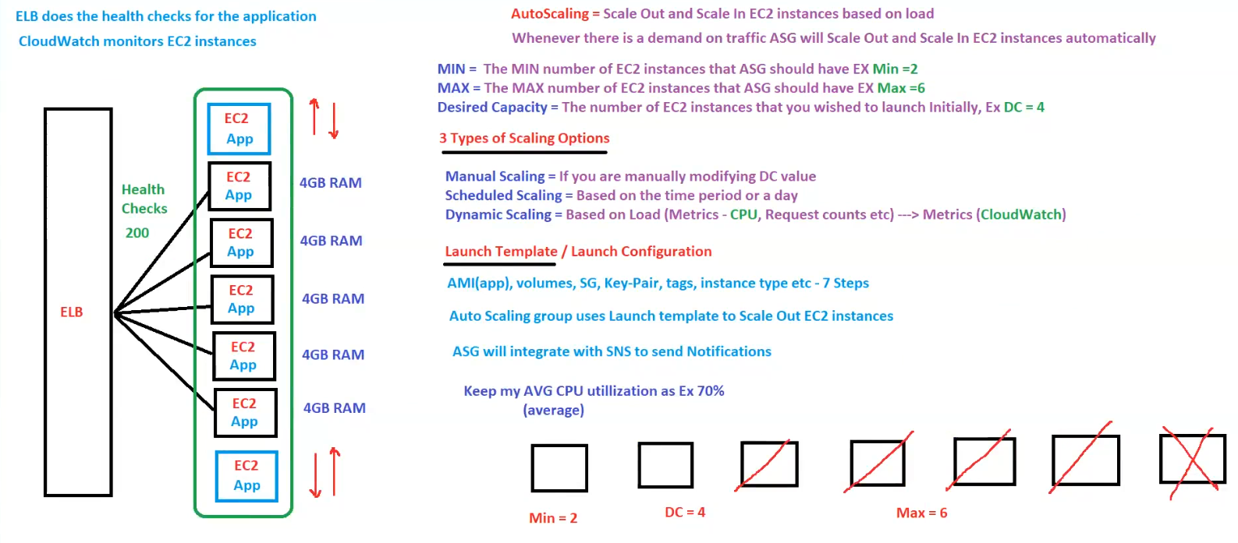

**AWS Auto Scaling & Load Balancing**

**1. Auto Scaling Overview**

* **Auto Scaling** helps **scale out (increase EC2 instances) and scale in (decrease EC2 instances)** based on demand.
* **Automatically adjusts the number of EC2 instances** to maintain application availability.

**2. Key Auto Scaling Parameters**

* **Min Instances (Min = 2)** → The minimum number of EC2 instances in the Auto Scaling Group (ASG).
* **Max Instances (Max = 6)** → The maximum number of EC2 instances in the ASG.
* **Desired Capacity (DC = 4)** → The initial number of instances to be launched.

**3. Scaling Options**

1. **Manual Scaling**
   * Manually change the **Desired Capacity (DC)** value.
2. **Scheduled Scaling**
   * Scale **based on a fixed schedule** (e.g., scale up at 9 AM, scale down at 9 PM).
3. **Dynamic Scaling**
   * Automatically scales based on **CloudWatch metrics** such as:
     + **CPU utilization**
     + **Number of requests**
     + **Network traffic**
   * Example: **Scale out when CPU utilization exceeds 70%**.

**4. Launch Template / Launch Configuration**

* Defines the settings for launching new instances in Auto Scaling.
* Includes:
  + **AMI (Application Image)**
  + **Volumes**
  + **Security Groups (SG)**
  + **Key Pair**
  + **Instance Type**
  + **Tags**
  + **Other EC2 configurations**.
* **Auto Scaling Group (ASG) uses the launch template** to scale out EC2 instances.

**5. ELB & CloudWatch Integration**

✅ **ELB (Elastic Load Balancer) performs health checks** to remove unhealthy instances.  
✅ **CloudWatch monitors EC2 instances** and triggers scaling actions.  
✅ **ASG integrates with SNS (Simple Notification Service) to send notifications** on scaling events.

**6. Summary**

* **ASG automatically scales EC2 instances based on demand.**
* **Scaling can be manual, scheduled, or dynamic.**
* **Launch Templates define EC2 instance configurations.**
* **ELB and CloudWatch monitor and maintain instance health.**

## Elastic Load Balancer

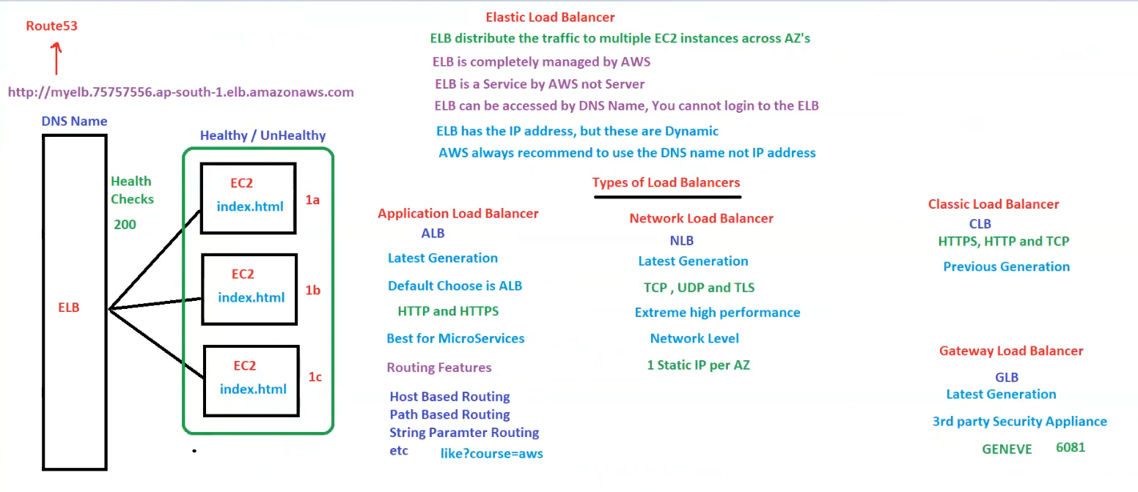

**AWS Elastic Load Balancer (ELB) Overview**

**1. What is an Elastic Load Balancer (ELB)?**

* **ELB distributes traffic** across multiple EC2 instances across different Availability Zones (AZs).
* **Managed by AWS** (Users cannot log into an ELB).
* **ELB assigns dynamic IPs**, so AWS recommends using its **DNS name instead of IP addresses**.
* **Performs health checks** to ensure traffic is sent to healthy EC2 instances.

**2. ELB Health Checks**

* ELB regularly **monitors the health of EC2 instances**.
* **Healthy instances (return HTTP 200 status) receive traffic**.
* **Unhealthy instances are automatically removed from routing**.

**3. Types of AWS Load Balancers**

**A. Application Load Balancer (ALB)**

* **Latest generation** (Recommended default choice).
* Supports **HTTP and HTTPS** traffic.
* **Best for microservices** and containerized applications.
* **Advanced Routing Features**:
  + **Host-based routing** (e.g., app1.example.com, app2.example.com).
  + **Path-based routing** (e.g., /api goes to one target group, /app goes to another).
  + **Query String & Header-based routing** (e.g., like?course=aws).

**B. Network Load Balancer (NLB)**

* **Latest generation**.
* Supports **TCP, UDP, and TLS**.
* Designed for **high-performance, low-latency applications**.
* **Operates at the network level (Layer 4 of OSI Model)**.
* Provides **1 Static IP per AZ** for better predictability.

**C. Classic Load Balancer (CLB)**

* **Previous generation** (older technology, less commonly used now).
* Supports **HTTP, HTTPS, and TCP**.
* **Limited features compared to ALB and NLB**.

**D. Gateway Load Balancer (GLB)**

* **Latest generation**.
* Designed for **3rd party security appliances**.
* Uses **GENEVE protocol (Port 6081)** for traffic forwarding.

**4. Route 53 Integration**

* ELB **can be mapped to a domain using AWS Route 53 (DNS Service)**.
* Example **DNS Name**:
* http://myelb.75757556.ap-south-1.elb.amazonaws.com
* **Allows traffic distribution across multiple AZs with a custom domain**.

**5. Summary**

✅ **Use ALB for HTTP-based applications and microservices**.  
✅ **Use NLB for high-performance, low-latency workloads**.  
✅ **Use CLB only for legacy applications**.  
✅ **Use GLB for security appliance integration**.  
✅ **Route 53 can map ELB to a custom domain**.

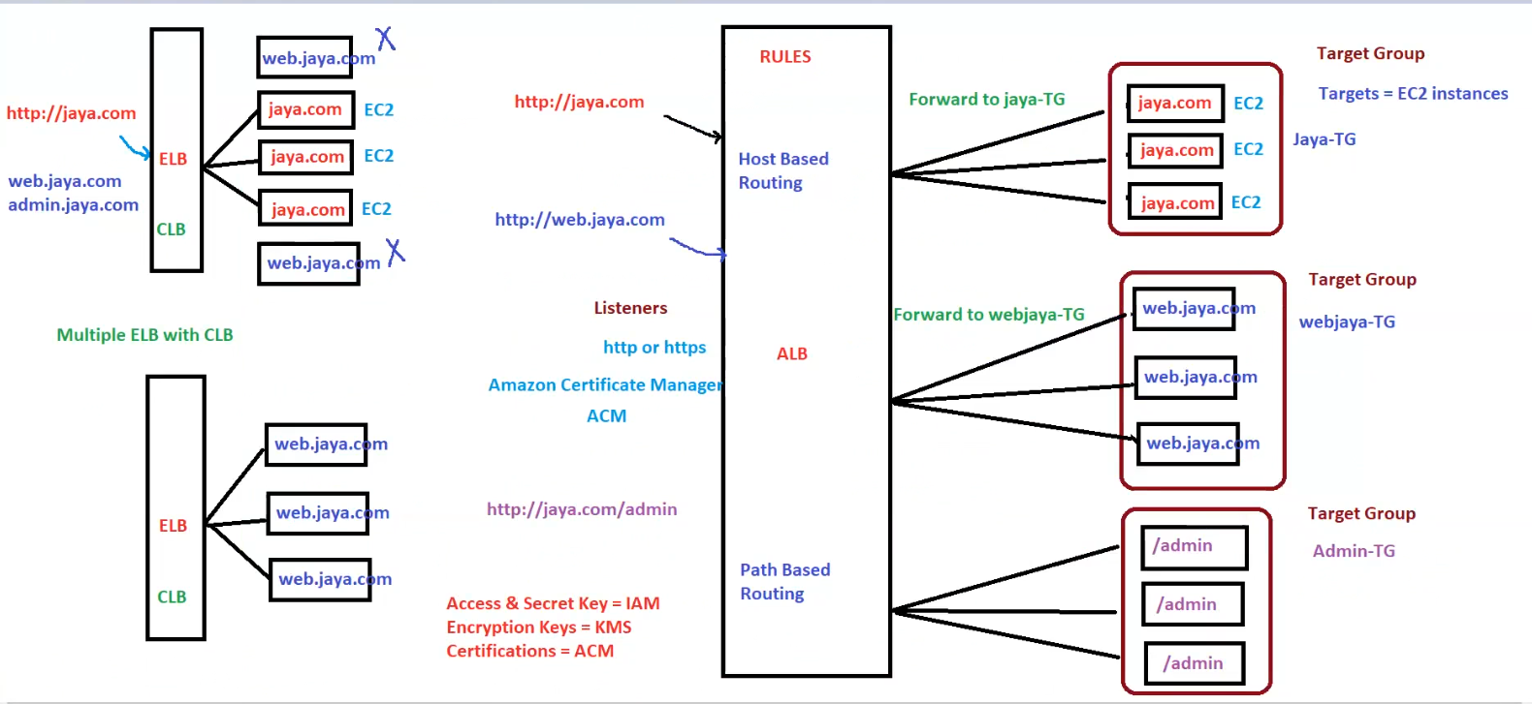

**AWS Load Balancer: Classic Load Balancer (CLB) vs. Application Load Balancer (ALB)**

**1. Classic Load Balancer (CLB)**

* **Operates at Layer 4 (Transport Layer)**.
* **Routes traffic to EC2 instances directly**.
* **Cannot do host-based or path-based routing**.
* **One-to-one mapping** between ELB and backend EC2 instances.
* **Less flexible and considered legacy technology**.

**CLB Example**

* **ELB distributes traffic to multiple EC2 instances.**
* Example:
* http://jaya.com → Routes to multiple EC2 instances
* web.jaya.com → Also mapped via CLB
* **Issue**: CLB does not support advanced routing, so all requests go to predefined instances without filtering.

**2. Application Load Balancer (ALB)**

* **Operates at Layer 7 (Application Layer)**.
* **Supports host-based and path-based routing**.
* **Routes traffic to target groups** instead of direct EC2 instances.
* **Supports SSL/TLS via AWS Certificate Manager (ACM)**.

**ALB Features**

✅ **Host-Based Routing** → Routes traffic based on domain name (e.g., jaya.com, web.jaya.com).  
✅ **Path-Based Routing** → Routes traffic based on URL path (e.g., jaya.com/admin).  
✅ **Target Groups (TG)** → Groups of EC2 instances for routing.

**ALB Example**

1. **Host-Based Routing**
2. http://jaya.com → Forward to jaya-TG (EC2 instances running jaya.com)
3. http://web.jaya.com → Forward to webjaya-TG (EC2 instances running web.jaya.com)
4. **Path-Based Routing**
5. http://jaya.com/admin → Forward to Admin-TG (EC2 instances running admin panel)

**3. ALB Components**

**Listeners**

* Listens for HTTP/HTTPS requests.
* Routes requests based on **rules**.
* Uses **Amazon Certificate Manager (ACM) for SSL/TLS**.

**Target Groups**

* **Each target group can have multiple EC2 instances**.
* Traffic is forwarded to instances within the corresponding target group.

**4. Security & Access Management**

* **IAM** → Manages access keys and authentication.
* **KMS** → Handles encryption keys.
* **ACM** → Provides SSL/TLS certificates.

**5. Key Differences: CLB vs. ALB**

| **Feature** | **Classic Load Balancer (CLB)** | **Application Load Balancer (ALB)** |
| --- | --- | --- |
| **Layer** | Layer 4 (Transport) | Layer 7 (Application) |
| **Routing** | Direct to EC2 | Target groups (TG) |
| **Host-Based Routing** | ❌ No | ✅ Yes |
| **Path-Based Routing** | ❌ No | ✅ Yes |
| **SSL/TLS Management** | Basic | **ACM Integration** |
| **Best For** | Simple Load Balancing | **Microservices, API Gateway** |

**6. Summary**

✅ **Use ALB for modern applications, microservices, and path-based routing**.  
✅ **Use CLB only for legacy applications that require basic load balancing**.  
✅ **ALB is more flexible with host-based and path-based routing**.  
✅ **Target Groups in ALB provide better traffic management**.

## Types of IPs

**AWS EC2 IP Addressing & Metadata**

**1. Types of IPs in AWS**

AWS provides **three types of IP addresses** for EC2 instances:

**A. Public IP**

* **Can be accessed from the internet**.
* **Optional** (not enabled by default).
* **Dynamic** (changes when EC2 is stopped and started).
* **Assigned automatically by AWS** if enabled.

**B. Private IP**

* **Cannot be accessed from the internet**.
* **Mandatory** (every EC2 instance has at least one private IP).
* **Static** (remains the same throughout the instance's lifetime).
* **Used for internal communication within VPC or VPN connections**.

**C. Elastic IP (EIP)**

* **Same as a Public IP but Static**.
* **Persists even after stopping and starting EC2 instances**.
* **Must be explicitly assigned to an EC2 instance**.
* **Up to 5 EIPs are free per AWS account**.
* **AWS charges for unassociated EIPs**.

**2. IP Assignment Options for EC2**

| **IP Type** | **Accessibility** | **Changes on Restart?** | **Use Case** |
| --- | --- | --- | --- |
| **Private IP** | Internal only (within VPC) | No | Internal communication |
| **Public IP** | Internet-accessible | Yes | Temporary external access |
| **Elastic IP** | Internet-accessible | No | Static public access |

**3. Instance Metadata & User Data**

**A. Instance Metadata**

* Contains **instance-specific information** (e.g., instance ID, AMI, region).
* **Accessible via CLI or URL**:
* curl http://169.254.169.254/latest/meta-data/
* Available in the **EC2 console (Instance Details section)**.

**B. User Data (Bootstrap Script)**

* **Script that runs at first boot of the instance**.
* Used for **automated configurations** (e.g., installing software, setting up the environment).
* **Runs only once** when the instance is launched.

| **Platform** | **User Data Execution** |
| --- | --- |
| **Linux** | Shell Script |
| **Windows** | PowerShell |

**4. Accessing EC2 Instances**

✅ **Instances with Private IP only** → Can be accessed via VPN or Bastion Host.  
✅ **Instances with Public IP** → Can be accessed directly from the internet.  
✅ **Instances with Elastic IP (EIP)** → Provides stable external access.

**5. Summary**

* **Public IPs are dynamic and change when restarting instances**.
* **Private IPs are static and used for internal communication**.
* **Elastic IPs (EIPs) are static and assigned manually**.
* **Instance Metadata provides system details, while User Data automates setup tasks**.

## EC2 7 Steps

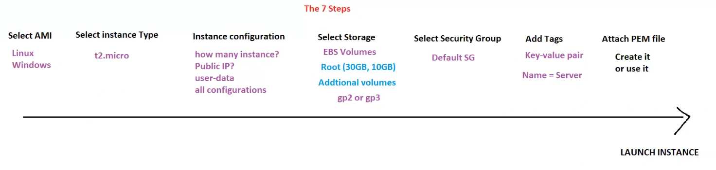

**AWS EC2 Instance Launch: The 7 Steps**

**Step 1: Select AMI (Amazon Machine Image)**

* **Choose OS for the instance**.
  + ✅ **Linux** (Amazon Linux, Ubuntu, RedHat, etc.).
  + ✅ **Windows** (Windows Server).
* **AMI contains the OS and pre-installed applications**.

**Step 2: Select Instance Type**

* **Choose instance size (CPU & RAM)**.
* Example: **t2.micro (1 vCPU, 1GB RAM, Free Tier Eligible)**.

**Step 3: Configure Instance**

* **Specify number of instances**.
* **Enable/Disable Public IP**.
* **Add User-Data (Bootstrap script for automation)**.
* **Other advanced configurations**.

**Step 4: Select Storage**

* **EBS Volumes (Elastic Block Store) for persistent storage**.
* **Root Volume**:
  + ✅ Default: **30GB (Linux), 10GB (Windows)**.
* **Additional Volumes**:
  + ✅ **gp2 or gp3 (SSD options)**.

**Step 5: Configure Security Group**

* **Select Security Group (SG)** to allow/deny traffic.
* **Default SG**:
  + ✅ **Allows outbound traffic, denies inbound by default**.
  + ✅ **Modify inbound rules to allow SSH (22) or RDP (3389)**.

**Step 6: Add Tags**

* **Key-Value pairs for better management**.
  + Example:
    - **Key:** Name
    - **Value:** Server

**Step 7: Attach Key Pair (PEM File)**

* **Create or use an existing key pair**.
* **Required for SSH (Linux) or RDP (Windows) access**.

**Final Step: Launch the EC2 Instance!**

🚀 **Click "Launch Instance" to start the EC2 server**.

**Summary**

* **Choose AMI, instance type, and configure settings**.
* **Attach storage, security groups, tags, and key pair**.
* **Launch the EC2 instance for use**.

## EC2 Hibernate

**EC2 Hibernate: How It Works & Key Considerations**

**1. What is EC2 Hibernate?**

* **Preserves In-Memory (RAM) state** when hibernating.
* **Boots much faster** since OS is not restarted.
* **RAM state is saved to a file in the root EBS Volume**.
* **Root EBS Volume must be encrypted** for security.

**2. Use Cases for EC2 Hibernate**

✅ **Long-running processes** that should resume quickly.  
✅ **Saving RAM state** to avoid reloading applications.  
✅ **Services that take time to initialize**, like databases or machine learning models.

**3. Key Requirements for Hibernate**

| **Requirement** | **Details** |
| --- | --- |
| **RAM Size** | Must be **less than 150GB** |
| **Root Volume** | Must be **EBS & Encrypted** (ISV is not supported) |
| **Hibernate Mode Limit** | **Max 60 days** |

**4. Summary**

* **EC2 Hibernate preserves RAM and enables faster boot times**.
* **Ideal for workloads that need to resume quickly**.
* **Requires encrypted EBS root volume**.
* **Not supported if RAM exceeds 150GB**.
* **Cannot hibernate for more than 60 days**.

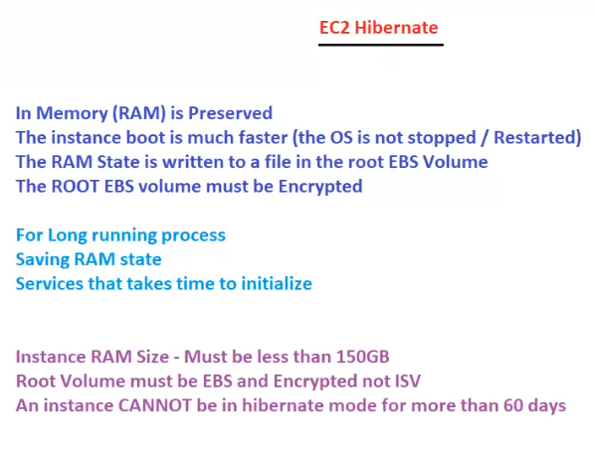

## AWS Global Accelerator (GA)

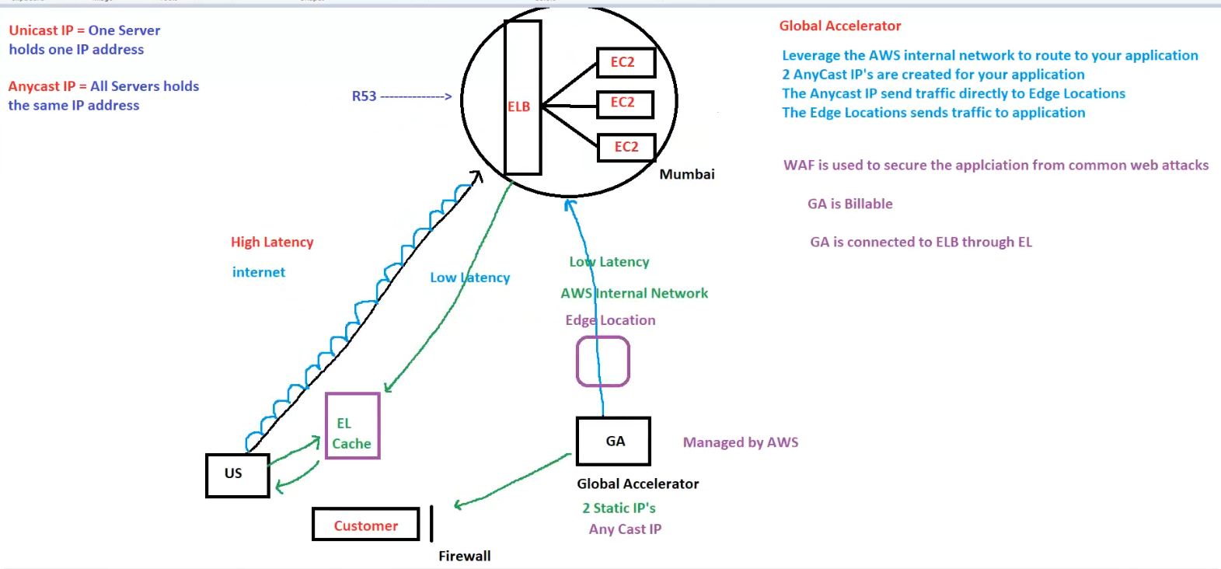

**AWS Global Accelerator (GA) & Anycast Routing**

**1. What is AWS Global Accelerator?**

AWS **Global Accelerator (GA)** improves **latency and performance** by using the **AWS internal network** to route user traffic efficiently.

✅ **Optimized for Low Latency**  
✅ **Uses AWS Edge Locations for Faster Routing**  
✅ **Bypasses Internet Congestion**

**2. How Global Accelerator Works**

1. **Uses Anycast IPs**
   * Two **static IPs** are assigned to the application.
   * All servers in the AWS region **share the same IP (Anycast)**.
2. **Routes Traffic to Edge Locations**
   * The **closest AWS Edge Location** processes the request.
   * Traffic **enters AWS’s private network**, reducing internet latency.
3. **Edge Location Sends Traffic to Application**
   * **GA connects to ELB (Elastic Load Balancer)**.
   * Traffic is forwarded to the nearest **EC2 instances**.

**3. Unicast vs. Anycast**

| **Type** | **Definition** | **Use Case** |
| --- | --- | --- |
| **Unicast IP** | One server holds one IP | Traditional networking |
| **Anycast IP** | Multiple servers hold the same IP | AWS Global Accelerator |

**4. Benefits of AWS Global Accelerator**

🚀 **Faster Application Performance**  
✅ **Lower Latency via AWS Backbone Network**  
🔒 **Security with AWS WAF (Web Application Firewall)**  
📌 **Provides 2 Static Anycast IPs**  
💲 **Billable AWS Service**

**5. Comparison: Global Accelerator vs. Route 53**

| **Feature** | **Global Accelerator (GA)** | **Route 53** |
| --- | --- | --- |
| **Purpose** | Improves latency using AWS backbone | DNS-based traffic routing |
| **Routing** | Routes traffic via **Edge Locations** | Routes via **DNS resolution** |
| **IP Type** | **Anycast IP (static)** | Resolves to different IPs |
| **Use Case** | Real-time, low-latency apps | General DNS-based routing |

**6. Summary**

* **AWS Global Accelerator uses Anycast IPs and AWS’s private network for low-latency routing**.
* **GA is connected to ELB and routes traffic via Edge Locations**.
* **It is a billable service but offers significant latency improvements**.
* **Works best for latency-sensitive applications like gaming, streaming, and financial transactions**.

## Application Load Balancer (ALB) with EC2 Instances

**Application Load Balancer (ALB) with EC2 Instances**

**1. Overview**

✅ **ALB distributes traffic** between multiple EC2 instances.  
✅ Uses **path-based routing** to serve different applications.  
✅ **Health checks** ensure traffic is sent to healthy instances.

**2. Components in the Architecture**

| **Component** | **Description** |
| --- | --- |
| **ALB (Application Load Balancer)** | Listens for HTTP (80) and HTTPS (443) |
| **Listeners** | Defines rules for routing traffic |
| **Target Groups (TG)** | Routes traffic to EC2 instances based on path |
| **APP-TG** | Serves index.html (public website) |
| **Admin-TG** | Serves /admin page (admin dashboard) |
| **Security Group (SG)** | Must allow HTTP/HTTPS traffic |
| **Health Checks** | Monitor instance health (200 response) |

**3. Steps to Set Up ALB with EC2**

1️⃣ **Launch 2 EC2 instances** in different AZs (1a, 1b).  
2️⃣ **Attach user-data script** to install HTTPD service (Apache).  
3️⃣ **Verify** that index.html loads in a browser.  
4️⃣ **Create a Target Group (TG)** for application servers.  
5️⃣ **Create an ALB** and link it to TG.  
6️⃣ **Add path-based routing rules**:

* / → APP-TG
* /admin → Admin-TG  
  7️⃣ **Use ALB DNS name** to access the website.

**4. User Data Script for EC2 Setup**

To install Apache and set up a website:

#!/bin/bash

yum install httpd -y # Install HTTPD service

service httpd start # Start HTTPD service

chkconfig httpd on # Enable on reboot

mkdir /var/www/html # Set up website directory

echo 'Hey!! This is my First Website on EC2!' > /var/www/html/index.html

For the **Admin Page**:

echo 'Hey!! This is my Admin Page!' > /var/www/html/admin

**5. Testing**

🔹 **Visit the ALB DNS name**  
🔹 Check: http://elbdnsname → Should show **index.html**  
🔹 Check: http://elbdnsname/admin → Should show **Admin Page**

**6. Key Takeaways**

🔹 ALB enables **path-based routing** for different target groups.  
🔹 EC2 instances run **Apache (httpd)** to serve webpages.  
🔹 Security Group must **allow HTTP (80) and HTTPS (443)**.  
🔹 **Health checks** ensure only active servers receive traffic.

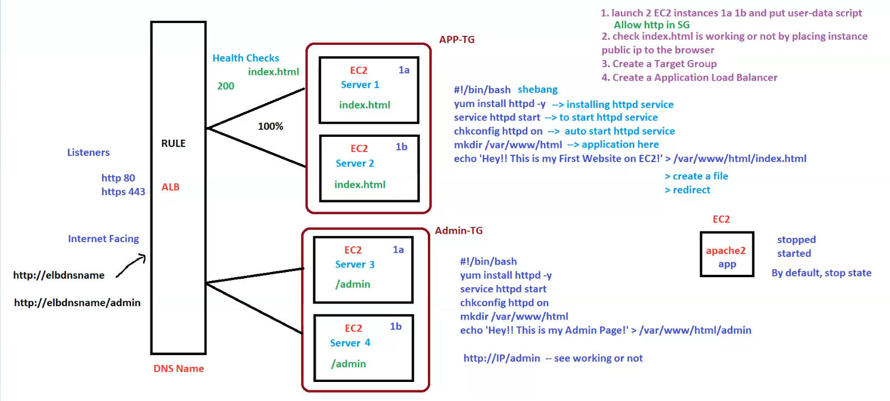

## Auto Scaling Group (ASG) with ALB and SNS

**Auto Scaling Group (ASG) with ALB and SNS**

**1. Overview**

✅ **Auto Scaling Group (ASG)** dynamically adjusts the number of EC2 instances based on demand.  
✅ **Application Load Balancer (ALB)** distributes traffic across multiple EC2 instances.  
✅ **SNS (Simple Notification Service)** sends notifications (SMS, Email) when scaling events occur.

**2. Components in the Architecture**

| **Component** | **Description** |
| --- | --- |
| **Auto Scaling Group (ASG)** | Manages EC2 instance scaling based on load |
| **Launch Template** | Contains AMI, instance type, user data, etc. |
| **Application Load Balancer (ALB)** | Balances incoming traffic to healthy EC2 instances |
| **Target Group (TG)** | Routes requests to EC2 instances |
| **CloudWatch Metrics** | Monitors CPU utilization and triggers scaling policies |
| **SNS Topic (AUTOTOPIC)** | Sends notifications for scaling events |
| **Subscription** | Users receive SNS alerts via SMS or Email |

**3. Steps to Set Up ASG with ALB**

1️⃣ **Create an Empty Target Group**  
2️⃣ **Create an ALB and attach Target Group (TG)**  
3️⃣ **Create a Launch Template** with the following:

* AMI (Amazon Machine Image)
* Instance type
* **User-Data Script** to deploy a web app
* Security Group (allow HTTP/HTTPS)  
  4️⃣ **Create an Auto Scaling Group (ASG)**
* **Min:** 2 instances
* **Max:** 10 instances
* **Desired Capacity (DC):** 4 instances
* **Scaling trigger:** Average CPU Utilization at 70%  
  5️⃣ **Attach ASG to ALB** so that traffic is distributed evenly  
  6️⃣ **Set up an SNS topic (AUTOTOPIC)**
* Subscribe users via **SMS/Email** to receive scaling alerts

**4. User Data Script for EC2 Setup**

To install Apache and deploy a basic webpage:

#!/bin/bash

yum install httpd -y # Install HTTPD service

service httpd start # Start HTTPD service

chkconfig httpd on # Enable on reboot

mkdir /var/www/html # Set up website directory

echo 'Hey!! This is my Website on with ASG!' > /var/www/html/index.html

echo 'Welcome to ASG Demo' >> /var/www/html/index.html

**5. Testing the Setup**

🔹 **Visit the ALB DNS name**  
🔹 Check: http://elbdnsname → Should show **"Hey!! This is my Website on with ASG!"**  
🔹 Increase **CPU load** on instances and observe ASG scaling behavior  
🔹 Check if SNS **sends notifications** when scaling events occur

**6. Key Takeaways**

🔹 **ASG ensures high availability** by adjusting instance count dynamically  
🔹 **ALB distributes traffic** evenly among EC2 instances  
🔹 **CloudWatch monitors CPU** usage and triggers ASG actions  
🔹 **SNS sends alerts** for scaling events via Email/SMS

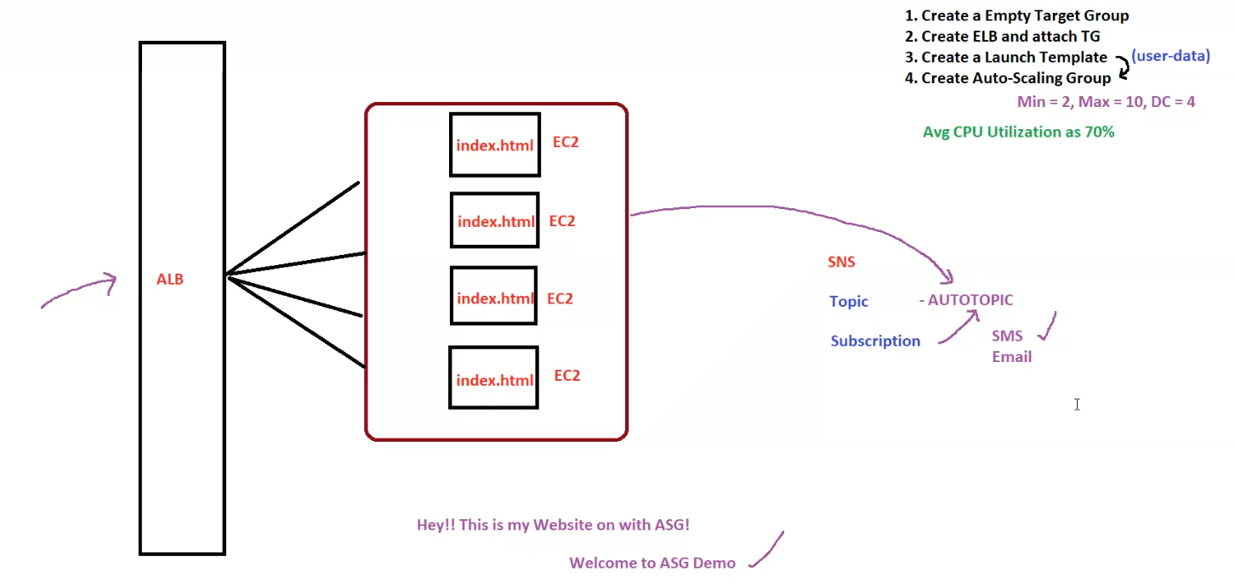

## AWS Lambda for Scheduled Start/Stop of EC2 Instances

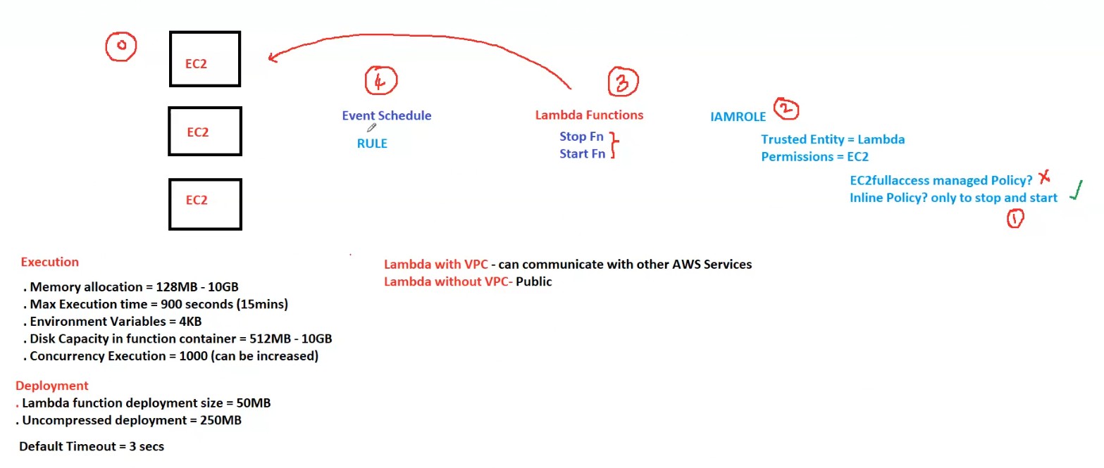

**AWS Lambda for Scheduled Start/Stop of EC2 Instances**

This diagram explains how to use **AWS Lambda** to automatically **start and stop EC2 instances** based on a schedule.

**1. Components in the Architecture**

| **Component** | **Description** |
| --- | --- |
| **EC2 Instances** | Compute instances that will be started/stopped |
| **Event Schedule (Amazon EventBridge Rule)** | Triggers Lambda at a scheduled time |
| **Lambda Functions** | Executes the start/stop actions on EC2 |
| **IAM Role** | Provides necessary permissions for Lambda to manage EC2 |

**2. Steps to Implement**

**Step 1: Create an IAM Role**

* **Trusted Entity:** AWS Lambda
* **Permissions:**
  + ❌ **Avoid using AmazonEC2FullAccess**
  + ✅ **Use an Inline Policy with only StartInstances and StopInstances permissions**

**IAM Inline Policy Example**

{

"Version": "2012-10-17",

"Statement": [

{

"Effect": "Allow",

"Action": [

"ec2:StartInstances",

"ec2:StopInstances"

],

"Resource": "arn:aws:ec2:*:*:instance/*"

}

]

}

**Step 2: Create Lambda Functions**

* **Lambda 1:** Stop EC2 instances
* **Lambda 2:** Start EC2 instances

**Python Code for Stopping EC2 Instances**

import boto3

def lambda_handler(event, context):

ec2 = boto3.client('ec2')

instances = ['i-0123456789abcdef0', 'i-0abcdef1234567890'] # Replace with your EC2 instance IDs

ec2.stop_instances(InstanceIds=instances)

return "Instances Stopped: " + str(instances)

**Python Code for Starting EC2 Instances**

import boto3

def lambda_handler(event, context):

ec2 = boto3.client('ec2')

instances = ['i-0123456789abcdef0', 'i-0abcdef1234567890'] # Replace with your EC2 instance IDs

ec2.start_instances(InstanceIds=instances)

return "Instances Started: " + str(instances)

**Step 3: Set Up EventBridge Rules**

* **Create an EventBridge Rule** to trigger the Lambda function at specific times.
* Example:
  + **Stop Function** → Every day at **10 PM UTC**
  + **Start Function** → Every day at **6 AM UTC**

**Cron Expressions**

* Stop EC2: cron(0 22 * * ? *) → Runs at 10 PM UTC
* Start EC2: cron(0 6 * * ? *) → Runs at 6 AM UTC

**3. AWS Lambda Execution Limits**

* ✅ **Memory:** 128MB - 10GB
* ✅ **Max Execution Time:** 900 sec (15 mins)
* ✅ **Disk Capacity:** 512MB - 10GB
* ✅ **Concurrent Execution Limit:** 1000 (default, can be increased)

**4. Key Considerations**

🔹 **Lambda in VPC?** If Lambda is inside a VPC, ensure it has correct security groups and subnets.  
🔹 **Timeout Settings:** Default is **3 seconds**, increase if needed.  
🔹 **EventBridge Rule:** Ensure the correct schedule is set in **UTC time**.  
🔹 **Security Best Practices:** **Use least privilege IAM permissions** (inline policy, avoid full access).

**5. Summary**

✅ **Automates EC2 start/stop, reducing costs**  
✅ **Uses EventBridge + Lambda for scheduling**  
✅ **Follows security best practices with minimal IAM permissions**  
✅ **Lambda with or without VPC considerations**